

**SRL Ltd November Open Dinghy Series**

**November 6th- 27th**

**Foynes Yacht Club**

**Venue & Organising Authority**

**Foynes Yacht Club**

**SAILING INSTRUCTIONS**

**1. RULES**

**1.1** Racing will be governed by the Racing Rules of Sailing, the prescriptions of the ISA, the Sailing Instructions and any amendments made there to.

**1.2** Competitors are reminded of Fundamental Rule 2, Fair Sailing. Fair Play and sportsmanship are important parts of our sport.

**1.3** Strict warning is given by Shannon Foynes Port Company that competitors must at all times keep well clear of Tugs and any commercial shipping vessels in the area. Competitors must comply with these warnings.

**2. NOTICES**

**2.1** Notices will be posted on the Notice Board. The notice board is located in the club house, next to the office.

**3. CHANGES TO THE SAILING INSTRUCTIONS**

**3.1** Any change to the SI’s will be posted on the notice board no less than 2 hours before the first race that it will affect.

**4. SIGNALS**

**4.1** Signals made ashore will be displayed on the flagpole at the clubhouse.

**4.2** When the ‘AP’ flag is displayed ashore ‘1 minute’ is replaced with ‘Not less than 30 minutes’ in the race signalled AP.

**5. SCHEDULE OF RACES**

**5.1** Dates of Racing:

Where possible it is intended to sail 2 races each day over the four-week period.

|  |  |
| --- | --- |
| Sunday - November 6th | FG – 1130hrs - 2 Races |
| Sunday - November 13th | FG – 1100hrs - 2 Races |
| Sunday - November 20th | FG – 1100hrs - 2 Races |
| Sunday - November 27th | FG – 1100hrs - 2 Races |

**5.2** A competitors briefing will take place prior to racing each Sunday. The time of the briefing will be 45 minutes before the scheduled warning signal on each Sunday.

**6. CLASS FLAGS**

6.1 The class flag will be described at the briefing each morning.

**7. RACING AREA**

**7.1** The racing area will be east of Foynes Island, in the vicinity of Mount Trenchard or in front of Foynes Yacht Club. The specific area will be outlined at the briefing each morning.

**8. COURSES**

**8.1** The courses to be sailed may be Windward-Leeward or Olympic type courses or as described in the briefing. See SI 8.2 for course diagram.

**8.2**

Olympic Course:

Start Lap 1: 1-2-3 Lap 2: 1-3 Lap 3: 1-2-3 Finish

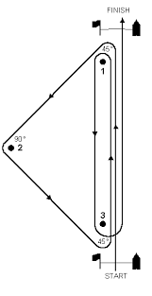

Windward – Leeward Course:

Start Lap 1: 1-2 Lap 2: 1-2 Lap 3: 1-2 Finish

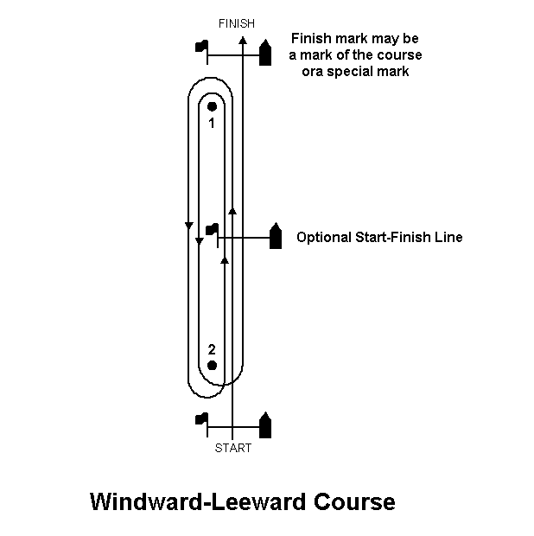

**9. MARKS**

**9.1** Windward, Leeward and Gybe marks will be tall orange buoys. Start/Finish marks will be small round orange buoys. Buoys will be outlined during the briefing each morning.

**10. THE START**

**10.1** Sequence

Warning signal times as per 5.1 above.

Races will be started in accordance with rule 26 (5,4,1, Starting Signal) or as described at morning briefing.

**11. START LINE**

**11.1** The starting line for committee boat starts shall be between the mainmast or improvised mast of the committee boat and the pin end mark, which shall be left to port when starting.

**11.2** Boats shall keep clear of the start line until their own warning signal.

**11.3** Boats shall not sail through the start line while start sequences other than their own are taking place.

**11.4** A boat shall start no later than 10 minutes after their starting signal.

**12. SHORTENED COURSE/ABANDONMENT/POSTPONEMENT**

**12.1** Shortened Course

**21.1.1** If the course is to be shortened at the start/finish line, Flag V shall be displayed with repetitive sounds at a mark on the course. Having rounded this mark, boats shall then proceed directly to the finish line. This is in addition to RRS 32.2

**21.1.2** A course may also be shortened at a course mark from a rescue/committee (finish boat), which will display flag S and make two sound signals. The finishing line shall be between the S flag and the relevant mark.

**12.1.3** Flag S displayed alone signals that all races not finished shall be shortened, flag S displayed superior to class flags signals that races for the relevant classes are shortened.

**12.2** Abandonment/Postponement BEFORE THE START

Abandonment before the starting signal/ postponement shall be as per RRS

**27.3** Flag signals will be made from the committee boat, starters hut or the top of the marina bridge as relevant.

**12.3** Abandonment AFTER THE START

Abandonment of a race after the start shall be as per RRS 32.1.

**13. THE FINISH**

**13.1** The finishing line shall be between the mainmast or improvised main mast of the committee boat and the pin end mark with the committee boat displaying a blue flag.

**13.2** Boats, having finished, shall not recross their own finishing line in the opposite direction.

**14. PENALTY SYSTEM**

**14.1** The penalty system shall be as per RRS 44.1. One turn for hitting a mark.

Two turns for boat-on-boat infringements.

**15. TIME LIMITS**

**15.1** The time limit is 55 minutes per race for all classes.

**15.2** After the first boat has finished the race officer may offer a finishing position to the boat still racing in the last place. The finishing position will be the number of boats finished and still racing plus one. A boat is not obliged to accept such an offer unless it is the last boat still racing. The race officer is not obliged to make such an offer. A boat that accepts such an offer will immediately cease racing, and the race Officer may repeat this process with the next boat. The offer may be made via rescue or support boat personnel. This changes RRS 35 and A4.

**15.3** A boat failing to finish within the 15 minutes of the fist boat will be disqualified.

**16. PROTESTS AND REQUESTS FOR REDRESS**

**16.1** All protests shall be notified in accordance with the RRS 61.1(a). (Protest flag is no longer required for boats under 6m).

**16.2** Protests and requests for Redress shall be written on an official protest form and left with the series organiser in the office.

**16.3** The protest time will begin 30 minutes after the last boat has finished the last race of the day and will last for 60 minutes. Hearings will be held as soon as possible.

**16.4** Details of protest hearings will be notifiable verbally.

**17. SCORING**

**17.1** The scoring system shall be as per RRS Appendix A – Low point System.

**17.2** One discard will be applied per 5 races up to a maximum of 1 discard.

**17.3** In the event of a series ties RRS appendix A8.2 will apply (best last race)

**17.4** A boat that did not finish, retired, or was disqualified shall be scored for the finishing place one more than the number of boats starting the race. A boat that did not start or did not come to the starting area shall be scored points for the finishing place one more than the number of boats entered in the series. This changes RRS A4.2.

**18. SAFETY**

**18.1** A boat that retires from a race shall notify the race committee boat or rescue boats as soon as possible.

**18.2**  Disclaimer of liability: Competitors participate in the series entirely at their own risk. See RRS 4, decision to race. Neither Foynes Yacht Club, the race committee, the organising committee, including those individuals who comprise them, are liable for loss or damage to boats or equipment, or for death or injury of competitors.

**18.3**  Competitors shall wear lifejackets or suitable personal floatation devices at all times. Wetsuits and dry suits are not suitable personal flotational devices.

**18.4** The attention of all competitors is drawn to RRS fundamental Rule 1.1 ‘helping those in danger.’

**18.5** Boats shall keep clear of Race committee vessels from the time the committee boat is on station prior to starting racing.

**18.6** All boats shall have a painter, with minimum diameter of 6mm and at least 3 metres in length, made fast to the bow.

**18.7** Strict warning is given by Shannon Foynes Port Company that competitors must at all times keep well clear of tugs and commercial shipping in the area. Competitors must comply with these warnings.

**19. SAIL NUMBERS**

**19.1** Sails shall have the correct sail number clearly displayed on both sides in accordance with class rules. Permission from the Race Committee shall be requested in writing before each day’s racing should a competitor wish to sail under a different sail number than with which they had entered.

**20. INSURANCE**

**20.1** Each participating boat shall be insured with adequate, valid, third-party liable insurance cover inclusive of a racing risks extension.

**21. HONORARY MEMBERSHIP**

**21.1** All competitors sailing in the series will be honorary members of Foynes Yacht Club during the event and will be bound by the rules of the club. Competitors are reminded that personal effects, gear, trailers, and other equipment are their own responsibility and neither the race committee or Foynes Yacht Club can be held liable for any damage, claim or loss.

**22. RUBBISH DISPOSAL**

**22.1** Boats shall not put rubbish in the water. Rubbish may be placed on board race and committee boats.